Package:

* Classes
* Interfaces
* Subpages

Types:

* Built in packages
* User defined packages

Built in packages:

These are the packages which are already available in java.

Ex: java, util, awt, io, lang, net, sql.

**User defined packages:**

These are the packages which are made by users, that contain their own classes and interfaces.

Advantages of having packages:

* Categorizes the classes
* Access protection
* Removes naming collisions

Hierarchy of packages:

**java**

Java package

Sub

**Button.class**

**ArrayList.class**

**String.class**

**System.class**

**awt**

**util**

**lang**

* (Package is the keyword used to create packages I .e (package package_name;))

Compiling and running java package programs:

If we are not using any IDE then we can compile and run using command prompt i.e

Javac -d . sample.java

Where in “-d” specifies the destination and “.” Specifies the current directory.

The above command is for compiling

Now for running the java file

Java packagename.filename

Accessing packages from other packages:

* Import package_name.*;
* Import package_name.class_name;
* Fully qualified

Importing using method 1:

* We can use all classes and interfaces in other packages, but you cannot access the subpackages.
* Import is the keyword used to access the other packages

Ex: import packagename.*;

Example program screen shot:

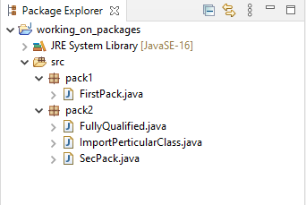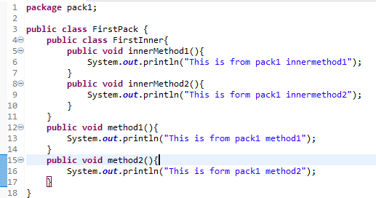

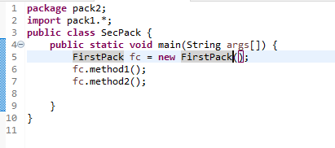

* Note that we cannot use import package_name.*; to access the inner class methods.
* So to overcome this we have the second method.

Importing using method-2:

In method – 2 we have to use the format of importing as,

Import package_name . class_name;

By using this method of importing a package we can access the methods available only in that particular package.

For an instance, lets take an example where in we have a inner class present and we will see the screen shot of those along with the output so that it becomes self-explanatory.



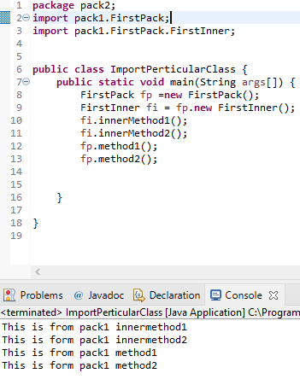

* In the above fig you can clearly see that we have FirstInner as an inner class in FirstPack, we have to use the import statement for accessing the methods in each of the classes individually.